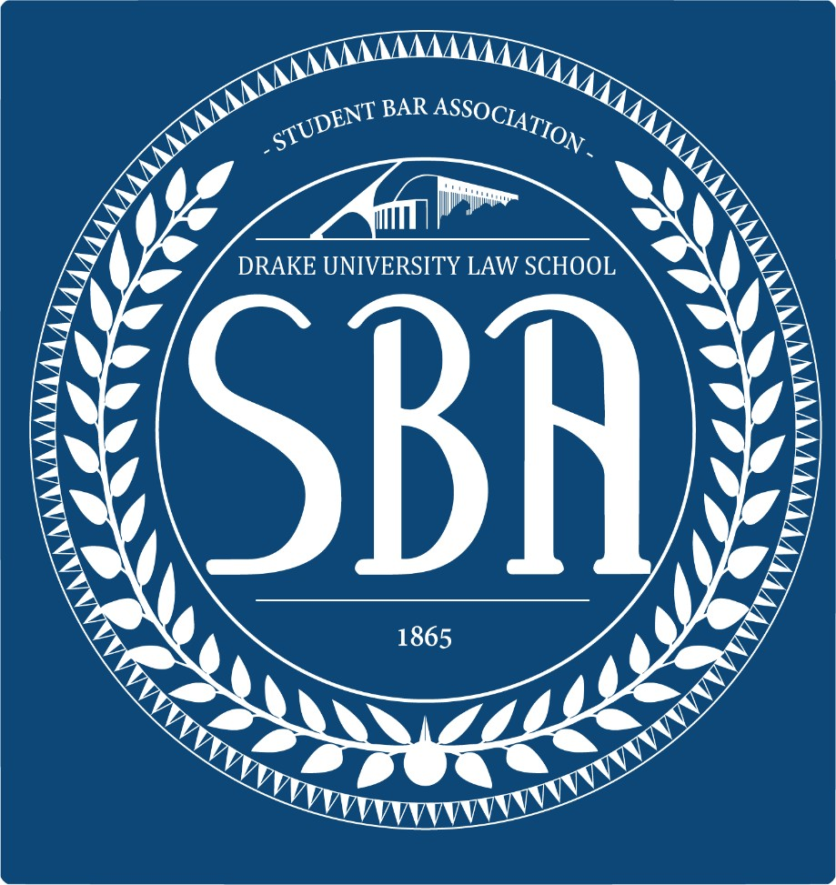Election Packet
Fall 2026
Drake University Law School Student Bar Association
Cierra Jackson, President
Brayden McKinney, Vice President

DUE: Tuesday, September 8th, 2026 by 5:00 PM. Please email to Cierra and Brayden.

Checklist:
☐ Signed Petition
☐ Letter of Intent
☐ Questionnaire
☐ Photo

Elections Timeline
  - Tuesday, September 1st, 2026: Petitions available on Microsoft Teams and the SBA Website.
  - Tuesday, September 8th, 2026: Completed election packets due electronically by 5:00 PM.
    - Send all election correspondence to cierra.jackson@drake.edu and brayden.mckinney@drake.edu. Please combine document files into a single PDF or document.
  - Thursday, September 17th, 2026: First round election day. Voting will take place online between 8:00 AM and 5:00 PM Central Time.
    - Results will be shared with candidates after polls close via phone. Please put a good contact number to reach you in the e-mail you send with the packet.

SBA Campaign Rules
  - Candidates must read SBA Bylaws Article V (available on Microsoft Teams under Law- Student Organizations Team under the SBA channel) prior to submitting their election packet.
  - Number of Posters per Designated Area
    - Four (4) up to - 8 ½” by 11"
    - One (1) up to 22" by 28"
  - List of Designated Areas
    - Cartwright First Floor
    - Cartwright Basement
    - Hall connecting Cartwright to Opperman and Opperman Student Lounge
    - NOTE: THERE SHALL BE NO POSTING OF ELECTION MATERIALS ON THE SECOND FLOOR OF CARTWRIGHT.
  - Where Campaign Posters May be Posted
    - On the brick surface between Cartwright and Opperman Hall
    - On the glass of the entrances to Cartwright Hall/Opperman Hall
    - Unused bulletin boards inside east staircase
    - On the wall above your head as you go to the basement (using putty only)
    - Lockers in Cartwright Hall basement with express permission of locker owner
  - Unless specifically indicated above, posting campaign materials anywhere else is prohibited. This includes but is not limited to:
    - Anywhere in Opperman Library, faculty bays, administrative areas, in any classroom, inside any bathroom, any journal or law review office, the SBA office, trophy cases, Career Development office, any elevator.
    - Please contact the Vice-President for any posting related questions.
  - Additional Rules Regarding Posters:
    - Posters must be installed using wall safe tape, such as blue painters’ tape or paint- safe putty. Absolutely no duct tape may be used.
    - Candidates may fill student folders with election materials, such as flyers, until Midnight the day before the election.
    - All posters of candidates MUST be removed before 5:00 p.m. on the day after the election.
  - Miscellaneous Additional Rules
    - Law students are prohibited from campaigning within the law school or on Drake University property with the use of food or beverages.
    - Law students are prohibited from campaigning within the law school or on Drake University property with the use of personalized gift items. A personalized gift is defined as any item(s) except those items which can be reasonably considered an extension of the person bearing them. Such items that can be reasonably considered an extension of the person bearing them may include, but are not limited to: stickers, buttons, or shirts.

    - A student may only run for a 3L, 2L or 1L Class Representative position and one other Officer position simultaneously. A candidate elected to both a 3L, 2L or 1L Class Representative position and another Officer position shall decide which position they will hold before the next regular meeting of the Student Bar Association.
    - Any individual who harasses, threatens, intimidates or interferes with a candidate during the course of an election will be reported to the Honor Board and may be disqualified from the election by approval of the Election Committee and three- fourths majority approval of the Officers of the Student Bar Association.
    - All candidates, including write-in candidates, shall follow the rules set forth in the Constitution and the Bylaws of the Student Bar Association.

Any violation of the rules may result in disqualification from the election or removal from office upon a hearing by the Elections Committee and a three-fourths majority vote of the Officers of the Student Bar Association.

If you have questions, please contact the Vice President, Brayden McKinney at mckinney.brayden@drake.edu.
SBA Candidate Questionnaire

Turn in this questionnaire with your petition. Please answer each question in 50 words or less. This questionnaire will be distributed amongst the law school along with the photo you submit. If you do not submit a photo, your Drake ID photo may be used.

What are your name and your pronouns?

Where are you from?

What did you do before law school?

Why did you decide to come to law school?

Please describe your previous leadership experience.

Why do you want to be in the SBA?

List three adjectives that describe yourself.

Tell us something interesting about yourself.

Petition for Election to the SBA Board

COMES NOW, __________________ and pursuant to Article VI, Sec. 3 of the Bylaws of the Drake University Law School Student Bar Association which provides:
The Vice President shall make election petitions available to all currently enrolled law students, who may be nominated for office by filing a petition with the Vice-President. The petition must be signed by at least twenty-five members of the law students the candidate will represent. Law students may sign more than one petition.
I submit the following petition for the position of: (fill in the blank)

1. | 14.
2. | 15.
3. | 16.
4. | 17.
5. | 18.
6. | 19.
7. | 20.
8. | 21.
9. | 22.
10. | 23.
11. | 24.
12. | 25.
13.
I certify that this petition was signed and attested before me prior to the applicable deadlines. I further certify by signature that I have read SBA Bylaws Article V and other election rules and will abide by the rules.
Date
Candidate Signature
Drake ID number

